Statistics 6371 Final Exam
MSDS Summer 2015

Note: Remember that a “complete analysis” includes stating the hypotheses, addressing the assumptions, doing the necessary statistical analysis, and writing a meaningful conclusion.

- (8pts) Suppose a researcher wants to design a new study with a power of 0.8 and a significance of 0.05 to test whether the caffeine content for a brand of coffee is really 100mg. A previous study gave a mean caffeine level for this brand of 110 mg and a standard deviation of 7 mg. Use PROC POWER to determine how many cups of coffee need testing to detect this difference.
  - The researcher would need a total of 7 cups of coffee to test.
- (10pts) In one weight-loss study 89 sedentary men were randomly assigned to either a special diet or exercise for a year. Forty-two men were placed on a diet and they lost an average of 7.2 kg with a standard deviation of 3.7 kg. The other 47 men were put on an exercise program and they lost an average of 5.3 kg with a standard deviation of 3.9 kg. For these data, researchers calculated three confidence intervals. They are given in the table below.
Confidence Level | Lower Limit | Upper Limit
90% | 0.6 | 3.2
95% | 0.3 | 3.5
99% | -0.2 | 4.0
  - Use the CI results to tell what p-value would be obtained in a two-sample t-test. (Hint: You can't give a precise value, only an interval. You can do the test to check but should report the answer to the question that is asked!)
    - At an alpha level of .01, the p value is likely not significant as the confidence interval crosses zero. However, the p value is likely significant at an alpha level of 0.05, as the confidence interval does NOT include zero. Therefore, the p value is likely greater than 0.01 and less than 0.05.
  - A critic complains that beginning weight is strongly associated with the amount of weight lost and that this experimental design does not control for this important factor. The physician conducting the study says that he doesn't need to worry about the weight of a subject at the beginning of the study. What feature of the experimental design guarantees that the conclusion is still valid even though the study did not account for beginning weight? Explain.
    - Random assignment takes care of the issue of beginning weight. Men with larger beginning weights are likely included in both groups : diet and exercise. There is a probability that one group is weighted heavier (no pun intended) with higher beginning weights, however our statistical tests do account for this chance, therefore the critic should not worry about the beginning weight of the subjects.
- (12pts) It is suspected that an unnatural craving for substances such as paint might influence lead poisoning in children. A study was conducted to investigate this hypothesis. Ten of 20 rats were randomly assigned to a calcium-deficient diet (experimental group) and 10 to a regular diet (control group). Each of the rats occupied a separate cage and was monitored to determine the quantity of a 0.15% lead-acetate solution that they consumed during the study period. The amount each consumed is shown below. The researcher was interested in whether the calcium-deficient diet increased the consumption of the lead-acetate compared to the control group.
Rat | 1 | 2 | 3 | 4 | 5 | 6 | 7 | 8 | 9 | 10
Control | 5.4 | 6.2 | 3.1 | 3.8 | 6.5 | 5.8 | 6.4 | 4.5 | 4.9 | 4.0
Experiment | 8.8 | 9.5 | 10.6 | 9.6 | 7.5 | 6.9 | 7.4 | 6.5 | 10.5 | 8.3
Perform a complete analysis of this data.
This is a one sided, two sample t-test.
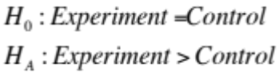
The mean lead-acetate solution consumed by the experiment group is 8.56 while the control group mean lead-acetate solution consumed is 5.06.
Equality of variance assumptions are met via graphical analysis (box plots) and an insignificant folded F of 1.53 with p of 0.54. The t-test is robust to departures from normality at moderate to large sample sizes and histograms do not violate normality egregiously.
The test statistic (t) is 5.85 with a 95% confidence interval of [2.24, 4.76]. The difference of means (3.5) is included in the interval and the interval does not cross zero, indicating a significant difference in groups.
The one sided p value confirms this significant difference at p <.0001. Thus, there is evidence of a difference in means of each group from this study and we can safely reject the null hypothesis that the experimental and control groups consumed an equal amount of the lead-acetate solution.
Based on a significant one sided p value of <.0001, this study shows evidence that calcium restricted rats consume more lead-acetate solution than rats on a normal diet. This result cannot be inferred to children, however, it can be used as a point of emphasis and caution about a child’s diet.

- (14 pts) Highlight all that are true:
- There are no situations where you can use your data to assess lack of model fit to the data.
  - Incorrect, there are many different ways to assess lack of model fit to the data via residual plots, r statistics, outlier analysis and other graphical means.
- As long as the sample size is large enough, the F-Test for the equality of variance is robust to normality.
- Adding more variables to the model will always increase the R².
- An r = 0 indicates that that there is no relationship between x and y.
  - Incorrect an r = 0 simply indicates there is likely no LINEAR relationship. You should also investigate graphics to confirm the relationship. A parabolic relationship may exist, for example.
- A causal relationship can be concluded if the p-value associated with the test is <0.001.
  - Incorrect, a causal relationship is only established by a randomized experiment.
- Type 1 error can be controlled by the researcher while type 2 error cannot.
  - Incorrect, increasing power can control type II error
- The slope of a categorical variable with two levels represents the difference between the group means.
  - As long as the categorical variable is the only variable in the equation. Once you add another variable, this is not true.
- (4 pts)You are half way finished!!! Visit the SMU website and identify the first chair of the Statistics Department. Also list 2 famous SMU alumni!
  - Paul Minton was the first statistics department chair. Robert Dennard (computer memory wizard) and Eric Dickerson, one of the best running backs of all time are famous SMU almumni.
- (24 pts) As cheese ages, various chemical processes take place that determine the taste of the final product. This dataset contains concentrations of various chemicals in 30 samples of mature cheddar cheese, and a subjective measure of taste for each sample (variable taste – where a larger score is better). The variables "Acetic" and "H2S" are the natural logarithm of the concentration of acetic acid and hydrogen sulfide respectively.
data cheese;
input Case taste Acetic H2S;
datalines;
1 12.3 4.543 3.135
2 20.9 5.159 5.043
3 39 5.366 5.438
4 47.9 5.759 7.496
5 5.6 4.663 3.807
6 25.9 5.697 7.601
7 37.3 5.892 8.726
8 21.9 6.078 7.966
9 18.1 4.898 3.85
10 21 5.242 4.174
11 34.9 5.74 6.142
12 57.2 6.446 7.908
13 0.7 4.477 2.996
14 25.9 5.236 4.942
15 54.9 6.151 6.752
16 40.9 6.365 9.588
17 15.9 4.787 3.912
18 6.4 5.412 4.7
19 18 5.247 6.174
20 38.9 5.438 9.064
21 14 4.564 4.949
22 15.2 5.298 5.22
23 32 5.455 9.242
24 56.7 5.855 10.199
25 16.8 5.366 3.664
26 11.6 6.043 3.219
27 26.5 6.458 6.962
28 0.7 5.328 3.912
29 13.4 5.802 6.685
30 5.5 6.176 4.787
;
run;
  - Which variable is the response variable?
    - The response variable is taste
  - What is the equation of the regression model?
    - Without running any graphical analyses the equation is:
      - y(taste) = -26.9397 + 3.8012(ln(acetic)) + 5.1456(ln(h2s))
  - Is the overall regression equation significant?
    - Yes, the overall F is 18.81 with a p value of < .0001
  - Are the slopes of the regression line statistically significant? Explain your answer.
    - Acetic is not significant at p = 0.41 while H2S is significant at 0.0002. This is likely due to co-linearity. Acetic and H2S are significantly linearly correlated at r = 0.62 and partial residual plots indicate we could likely drop acetic from our equation.
  - Interpret each slope and provide confidence intervals for each.
    - Acetic has a 95% confidence interval of [-5.44,13.04] while H2S has a 95% confidence interval of [2.66,7.63], confirming that acetic does indeed cross zero and confirming the insignificant p value. Since both variables are logged transformed, interpretations are different from the standard procedures associated with OLS. For each doubling of acetic acid content there is a ln(2)(3.8012) = 2.63 unit increase in taste score, all other variables held constant. The same interpretation holds for H2S. For each doubling of H2S, there is a ln(2)(5.1456) = 3.57 unit increase in taste, all other variables held constant.
  - Identify any leverage points in the data using any measure you like. Give a definition of the measure you chose. If you make your decision on the basis of several measures, then explain only one of them. If there are no leverage points, then explain why you came to that conclusion.
    - Observation 26 has the highest leverage at 0.2598, which means it has a high potential for influence based on an arbitrary cut off of 0.2 (2*3)/30. However, the overall influence of the observation on the regression is low, with a cook’s d of 0.001. Leverage measures the potential an observation has on influencing the regression model and measures the distance between its explanatory variable and the average of all explanatory variable values. We see that observation 26 should be investigated based on leverage, however, utilizing additional methods for measuring influence, we are not too concerned with observation 26.
  - What is the predicted taste score for an individual piece of cheese that has an acetic score of 200 and a hydrogen sulfide score of 1000? Provide the appropriate 95% interval for your estimate.
    - The predicted taste score is 28.74. The standard error when adjusting the parameters for ln(200) and ln(1000) utilizing computer centering is 2.72. The total d.f. for the model is 27 with a critical value of 2.05. The confidence interval half width is 5.58, meaning that our confidence interval is 28.74 +- 5.58 = [23.16, 34.32]

  - Create a new column that divides the cheeses into two categories: Those with ln(H2S) scores above 6 and below 6. Now fit a model that predicts taste using acetic and the new categorical variable you created. Fit the full model that allows for different slopes and intercepts. You do not need to conduct a full analysis here, just answer this one question: Are the slopes of the lines (taste v. acetic – not sure what this means) different based on high or low H2S? Provide pvalues and a plot.
    - The full model that allows for different slopes contains an interaction variable. In this case, the interaction variable is the categorical variable * acetic. The parameter estimates and p values are as follows:
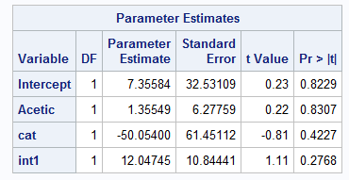
The slopes of the lines are also different based on high or low H2S. If H2S is greater than six, the slope is significantly greater in the equation:

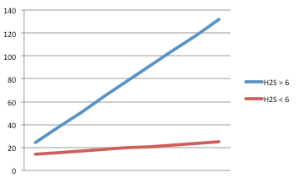

- (20 points) Salary information was obtained about the starting position players on two major league baseball teams, the Seattle Mariners and the New York Yankees. The salaries are listed below in millions of dollars:
Position | 1st B | 2nd B | 3rd B | SS | RF | CF | LF | C
Seattle  NYY | 1.4  20.6 | 2.25  6.0 | 13.4  33.0 | 2.3  21.6 | 18.0  6.55 | 2.05  13.0 | 2.0  13.0 | 7.66  13.1
The following table gives the data rearranged in ranks.
Position | 1st B | 2nd B | 3rd B | SS | RF | CF | LF | C
Seattle  NYY | 1  14 | 4  6 | 12  16 | 5  15 | 13  7 | 3  9.5 | 2  9.5 | 8  11
  - How did two observations get the rank 9.5?
    - Centerfield and left field for the Yankees ended in a tie (13.0), so an average was taken on observations 9 and 10 in the ranking, resulting in 9.5 for both observations.
  - Perform a Wilcoxon test to see if salaries differ between the two teams. Perform a complete analysis.
    - Based on a non parametric Wilcoxon rank sum test where salaries are ranked (ties being averaged), the sum of scores are as follows:
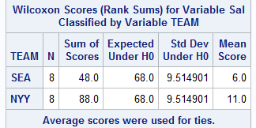
From the rank sum table, it’s obvious that the New York Yankees’ salaries are ranked much higher than the Seattle Mariners’ salaries with a mean score of 11 vs Seattle’s mean score of 6.
To test if this difference is significant, an exact and normal approximation was used via a Z statistic.
Based on a two sided p-value of 0.0175, there is evidence based on this study that the Yankee’s salaries is greater than the Seattle Mariners’ salaries. The normal approximation tells the same story at a two sided p value of 0.0292.
Based on the results of this observational study, there is evidence to show that the New York Yankees spend more money on their players than do the Seattle Mariners.

- (10 pts) Consider the following set of scores, which represents the age of 25 automobile salesmen in Europe.
43 | 26 | 30 | 27 | 40
35 | 48 | 36 | 47 | 41
34 | 45 | 30 | 38 | 33
35 | 44 | 24 | 33 | 40
31 | 23 | 29 | 37 | 28

Use SAS to plot the data. Interpret your plot, and explain why you chose that particular type of plot for these data.
Based on the sample taken, the age of automobile salesmen in Europe ranges from 23 to 48. The sample is normally distributed with a mean age around 36. I chose to use proc univariate with a histogram because we are dealing with one variable: age. The histogram will provide us with initial visuals to determine if transformations are needed, where about the mean lies in the distribution and the range of the data in one chart.
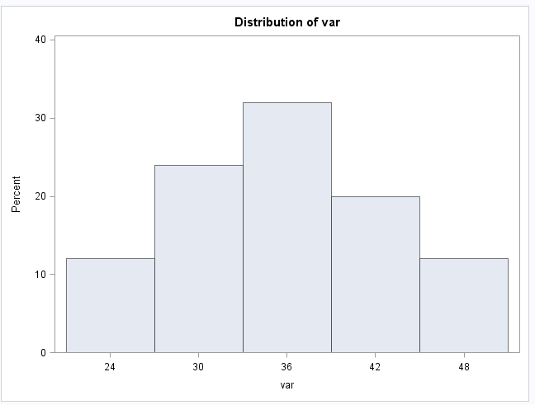

Bonus (5 pts)
Use the CityRate data set for this question. We want to know if there is a difference between the mean (or median) auto interest rates in Dallas and the North, East and West. To do this, consider Chicago and Boston to be in the North. Let Jacksonville and New York represent the East. And let Phoenix, San Diego, LA and Seattle represent the West. You may choose your significance level …. but be sure and report it. You may use confidence intervals and / or hypothesis tests (pvalue) to answer this question. Pretend you are writing to a client who has only a basic understanding of statistics.

Dear Client,
Based on an analysis of the auto interest rate loans in four different regions: Dallas (South), North, East and West, we have determined that auto interest rates are indeed different in at least one of the regions. We analyzed rates in the following cities and assigned each city to the following regions and areas:
City | Region | Area
Dallas | South | Southwest
Phoenix | West | Southwest
Los Angeles | West | Southwest
Seattle | West | Southwest
San Diego | West | Southwest
Boston | North | Northeast
Chicago | North | Northeast
Jacksonville | East | Northeast
New York City | East | Northeast

For instance, the south (Dallas) and the west tend to be roughly the same with an average difference of roughly half a point (0.53%) greater for interest rates in Dallas. However, based on the procedure used in our analysis differences can range from -0.4 points to 1.5 points, allowing us to safely say there is evidence based on the data and procedures used of no difference between Dallas and Western interest rates.
That being said, both Western region and Dallas auto interest rates are significantly different from Eastern and Northern auto interest rates. In fact, when contrasting western rates and Dallas rates as a group against eastern and northern rates, we were able to find a significant difference between the two groups. When comparing the regions individually, the following table lists the individual significant differences, and what we’d expect to see as a range of differences in auto interest rates based on a standard 95% level of confidence in our procedures:
Region Comparison | Difference of Means (%) | Range of Rates (%)
Dallas vs East | 1.68 | 0.61 to 2.76
Dallas vs North | 1.89 | 0.82 to 2.96
West vs East | 1.15 | 0.33 to 1.97
West vs North | 1.36 | 0.54 to 2.17

To summarize: there is evidence to show based on the observational data utilized that Dallas and the Western region have higher interest rates than Eastern and Northern regions.
When grouping Dallas and West into an area called ‘Southwest’ and grouping East and North into an area called ‘Northeast’, the total difference in auto interest rates is 1.4% greater in the southwest with a significance of p <.0001 (very significant), ensuring that the result from our analysis was not obtained by random chance. Further, the range of differences in rates between Southwest and Northeast regions is 0.9% and 1.8% greater in the southwest.
We hope this analysis is useful for your future endeavors in analyzing auto interest rates in the United States. However, a word of caution, as this is an observational study, please note that being in the southwest area does not cause rates to be higher, there is simply an association. We would also caution you to use your good judgment when inferring these results to cities not included in our analysis.

Sincerely,
SMU Data Dudez

